Q1- List the details of the emps whose Salaries more than the employee BLAKE.



Q2- List the emps whose Jobs are same as ALLEN

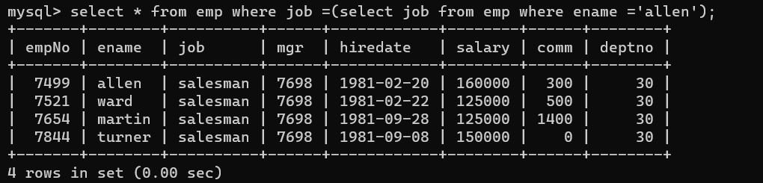

Q3- List the Emps whose Sal is same as FORD or SMITH in desc order of Names

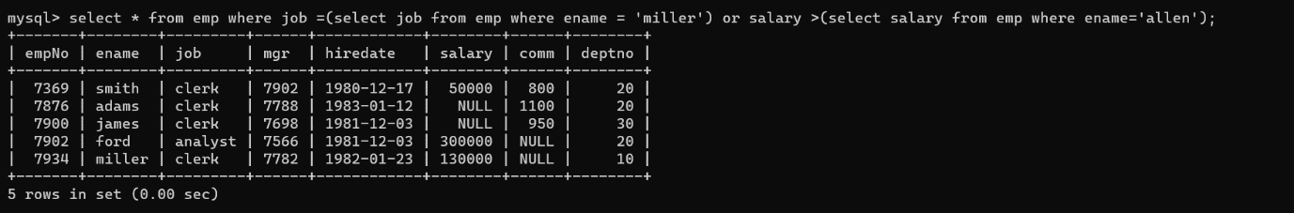

Q4- List the emps Whose Jobs are same as MILLER or Sal is more than ALLEN

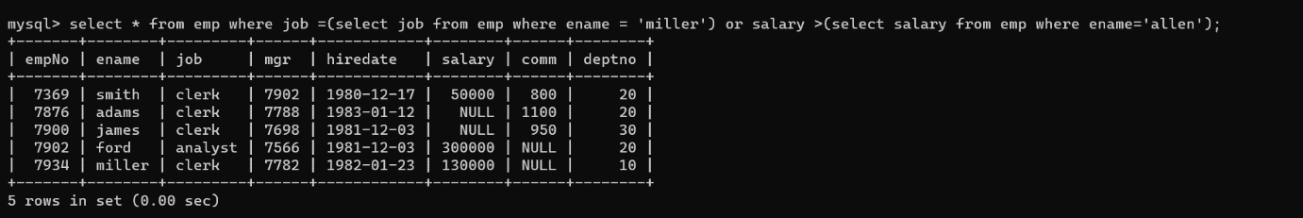

Q5- Find the highest paid employee of sales department

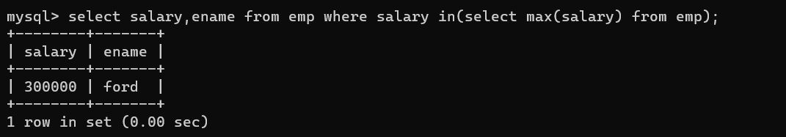

Q6- List the employees who are senior to most recently hired employee working under king

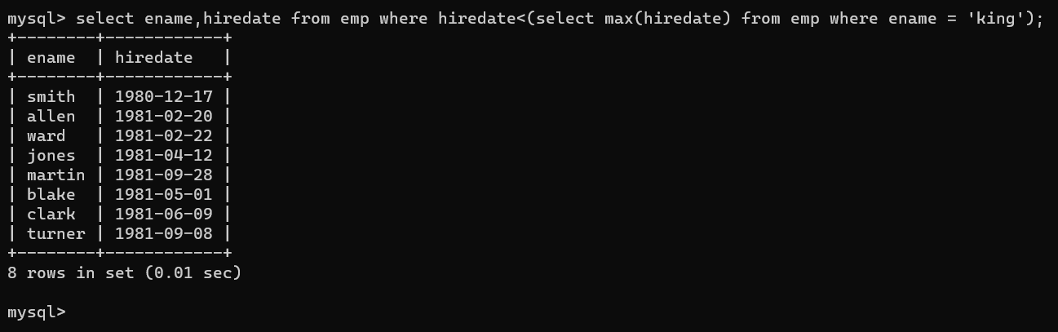

Q7- List the names of the emps who are getting the highest salary dept wise

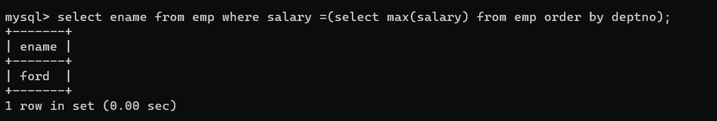

Q8- List the emps whose salary is equal to the average of max and minimum



Q9- List the emps who joined in the company on the same date

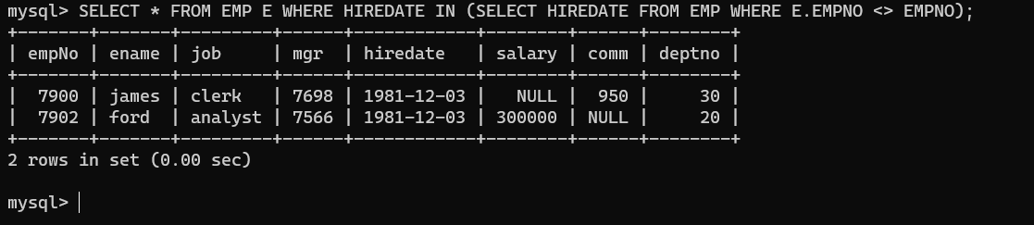

Q10- Find out the emps who joined in the company before their Manager.

